Finding Scholarships in Naviance: Parents
This document has instructions on how to search for scholarships in Naviance. If you follow it from beginning to end, you should be able to easily sort through the many scholarships available to students through Naviance!
- Log into your Naviance Account
  - From http://washburn.mpls.k12.mn.us/, hover over Parents
  - Click on Naviance
  - Enter your user-name and password
    - If you can’t get in, e-mail kevin.salkas@mpls.k12.mn.us to get access.
- Click on the Colleges Tab located on the top of the page.
- Click Scholarship List. It will be near the bottom.
  - This list is ALL of the active scholarships.
  - To sort by date, click Deadline
  - To sort by merit based or need based, click either Merit Based or Need Based
  - Clicking any of the headings twice will reverse the order.

*Don’t use Scholarship Match as it is not very accurate. For example, if a scholarship is listed as a gender based scholarship and you have indicated a gender, it will match you. Thus, gentlemen are matched with women’s math scholarships. Unfortunately this is controlled by Naviance, not the counseling staff.

- You can sort for specific scholarships as well! This is helpful if you’re looking for scholarships based on your academic interest, gender, ethnicity, first generation status, etc.
  - Just underneath the heading there is a drop down menu that says, “Browse by Category”
  - Click the “Select Category” button and then select the category you’re looking for.
- To view a scholarship, click it. This will open a new information page.
  - Most important is to find the website affiliated with each scholarship as it will have the most up to date information available.
  - You can also download some of the applications directly from Naviance as well.
FINDING SCHOLARSHIPS EXTENSION
Finding scholarships is nearly as much work as finding a college. To help ease the process, Naviance has a tool built in where you can save scholarships for which you intend to apply. This is a nice way to trim your list and organize yourself. It isn’t perfect, in fact it’s a little clunky, but it does serve its purpose and families from last year said it was helpful to them. Instructions are below.
BUILD YOUR SCHOLARSHIP LIST IN NAVIANCE
- Log into Naviance
- Search for Scholarships (see first page)
- When you have a scholarship you want to save, go to the listing page where you found it. (You can do this by hitting back on your browser from the Naviance Scholarship Page. )
- Select the scholarship(s) you want to save click the box next to the scholarship. 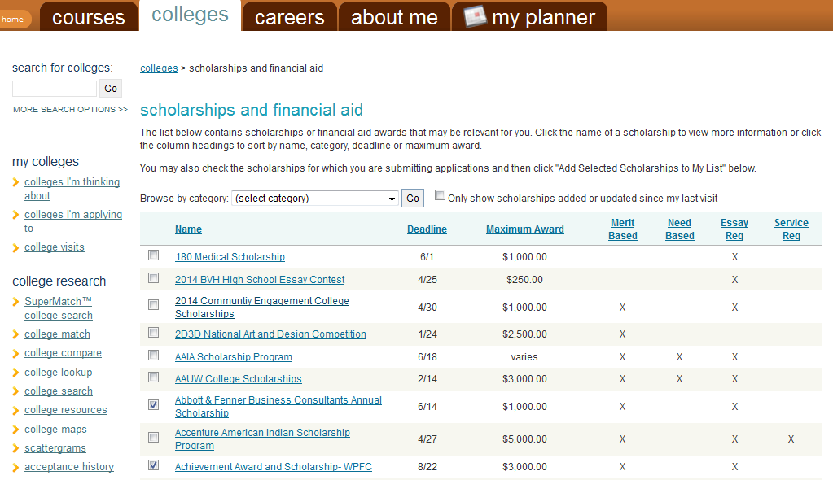

- Scroll to the bottom of the page
- Click, “ Add Selected Scholarships to my List”
- Enter in the amounts of each scholarship.
- Don’t worry about the “Status” This is where Naviance is clunky, just ignore it.
- To access these scholarships, click “Edit Scholarships” and then you can click into the scholarship page again.
- You now have a trimmed list of scholarships that you can keep track of in Naviance!

